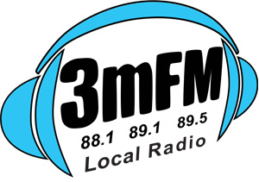
10B Williams St/P.O. Box 144, Inverloch VIC 3996
P: 5674 1900 E: radio@3mfm.com.au
W: www.3mfm.com.au
SOUTH GIPPSLAND RADIO 3MFM INC. Vic. A 0044149S
ABN 29 019 110 779

3mFM VOLUNTEER APPLICATION Date: ____________

YOUR DETAILS

Given name __________________________ Surname _____________________________ Age _______

Address ______________________________ Town __________________________________________
__
Telephone (Home)_____________________ (Work) _____________________________________________

Mobile ______________________________ Email _____________________________________________

Availability________________________________________________________________________________

_________________________________________________________________________________________

Areas of interest – please circle or highlight the areas listed and/or add your own

Presenter – Live to Air | Presenter – own show | Production
Tech Support | Fund Raising | Finances
Administration - (good with computers) | Administration – General | Events eg Trivia Night, Markets
Bingo | Marketing | Grants
_________________________________________________________________________________________
Have you been involved with any radio station before? If so, which one(s)? What did you do?
_________________________________________________________________________________________

_________________________________________________________________________________________

Volunteer Experience_______________________________________________________________________

_________________________________________________________________________________________
Emergency Contact Details
Given name __________________________ Surname ______________________________

Telephone (Home) __________________________ (Work) ______________________________
Are you a member of 3mFM? YES/NO Please attach a recent resume or relevant documents.
Volunteer Applicants are subject to an interview and approval by 3mFM's Board of Management at their monthly meeting, so it may be a few weeks before being notified of their decision. You will be invited to an orientation session if your application is approved, where your training will begin. If you are not a 3mFM member please become one, as all volunteers are required to be members of 3mFM.
We will be in touch, so in the meantime keep listening, and thank you for your application.

Please return your application to 3mFM - contact details above

X:\Volunteers\Volunteer Forms\3mFM Volunteer Application.docx

